"There is no elevator to success. You have to take the stairs"
English Exam
امتحان في اللغة الانجليزية للصف الرابع

الاسم:
الصف : الرابع الشعبة:
اسم المدرسة:

عزيزي الطالب،
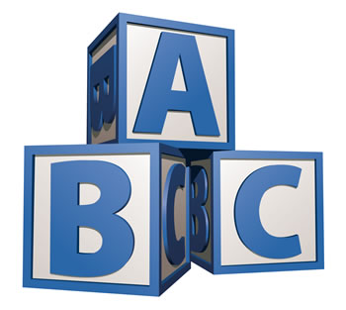
أمامك امتحان في اللغة الانجليزية. اقرأ بتمعُّن جميعَ المهمّات، ثمَّ أجِبْ بإمعان عن جميع الأسئلة.
 قبل تسليم ألامتحان افحصْ إجاباتِك جيّدًا
وصحِّح بحسب الحاجة.
نتمنّى لك النجاح!

Reading Comprehension (40 Points)
اقرأ النص التالي، ثم أجب عن الاسئلة التي تليه باللغة الانجليزية

Facts about Pandas
- Pandas live in China.
- Pandas have big white heads and bodies.
- Pandas are always hungry and eat all day.
- Baby pandas are pink.
- Pandas are bears with black and white spots.
- There are only 1000 pandas living in the forests in China.
- Pandas eat bamboo leaves from bamboo trees.
- Pandas have small black ears, black eyes and black legs.
- Baby pandas drink their mother's milk for 6 months.
- Pandas live in the forests in the mountains.
- Pandas live in forests with bamboo trees.
- Pandas like to run and play.

- أكمل بطاقة الحقائق عن دب الباندا.

Name: Panda
- What color are pandas?
- What do they eat?
- Where do they live?
- What do they like to do? | 1.
- What do they like to do? | 2.

- أكمل الجمل بواسطة الكلمة have أو has.

- A panda ________ a white body.
- Gorillas ________ long arms.
- Monkeys ________ small ears.
- Zebras ________ black and white stripes.
- A giraffe ________ a long neck.
- An elephant ________ a long nose.

- صنّف الكلمات إلى مجموعات.
glue | cake | cheese | scissors | chocolate | dates
drum | grandfather | grandson | guitar | ice-cream | mother
bananas | nuts | paper | chips | pencils | apples
son | twins | brother | pen | teacher | notebook

People | Food | Things in a school bag | Things you play music on

- أكمل الجمل التالية مستعينا بالكلمات في المخزن.
hear | year | July and August | week | begins | birthday

- When is your ___________? | d. I can _______ my teacher.
- There are 7 days in a _______. | e. School ______ at 9 o'clock.
- There are 12 months in a _______. | f. There is no school in _______

- لائم التوقيت مع الجمل.
It's six o'clock | It's nine o'clock | It's three o'clock
It's two o'clock | It's twelve o'clock | It's eleven o'clock
02:00 ______________ 11:00 ______________
06:00 ______________ 03:00 ______________
09:00 ______________ 12:00 ______________
- ماذا ترى في الصورة.
