On the week end we wake up early and go for a hike on the mountain. It is so nice to smell the fresh air and see the wild animals. We stay there for about three hours and bring our lunch with us. As you can see my family loves nature.

ANSWER THESE QUESTIONS

1.What does Annie love to do?
……………………………………………………………………………
2. Who does she walk with?
…………………………………………………………………………
3.Where does she live?
……………………………………………………………………………
4. How long does she walk ?
……………………………………………………………………………
5.What time does she arrive at school?
……………………………………………………………………………
6.Where does her father work?
………………………………………………………………………
7. What do they do on the week end?
……………………………………………………………………………

ANSWER TRUE OR FALSE
1.Annie is a vet.
(t) ……………… (f)……………………

2.Annie does not like the mountain.
(t) ……………… (f)……………………

3. Annie lives in the city.
(t) ……………… (f)……………………

4. Her father is a farmer.
(t) ……………… (f)……………………

5. They seldom walk on the mountain.
(t) ……………… (f)……………………

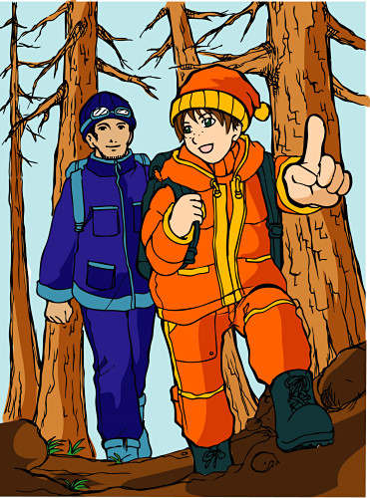

My name is Annie and this is what I normally do.
I love to walk on the mountain. During the week I
wake up early and go for a small walk on the mountain.
I usually go with my father or my brother. We like
to get some fresh air before we start our day. We
live in the country far away from the city. We think
that our country life is wonderful because we are
away from the noise and pollution of the city. We
often walk for about one-half hour and then return to
our home. I always take my bus after our walk and
at about 8:30 a.m. and arrive at at school at 9:00 a.m.
My father takes his car and goes to town to
work. He works at a veterinary clinic. He is a vet and
loves to help animals. We have 3 dogs and two cats.

Fill in the gap with the right tense of the verb.

Annie_________( like) to walk on the mountain. During the week she ___________(wake up) early and ___________(go) for a small walk. She usually ________(go) with her father and brother. She__________(like) to get some fresh air. She_______ (live) in the city .
She always________ (take) the bus at 8:30. a.m. and ______(arrive) at school at 9:00 a.m.
Her father____________(take) his car and_________(go) to town to work.
He__________(work) at a clinic. He__________(love) animals.
They_______(like) to go to the mountain on the week end and___________(see) the animals.
Annie________(stay) there for about three hours with her family. Annie’s family ______(love)
nature.

ANSWER KEY

1.What does Annie love to do?
……She loves to walk on the mountain.
2. Who does she walk with?
……She walks with her father or brother.
3.Where does she live?
………She lives in the country.
4. How long does she walk ?
…She walks for one-half hour.
5.What time does she arrive at school?
…She arrives at 9:00 a.m.
6.Where does her father work?
…He works at a vetenary clinic.
7. What do they do on the week end?
..They hike on the mountain.

ANSWER TRUE OR FALSE
1.Annie is a vet.
(t) ……………… (f)……f………………

2.Annie does not like the mountain.
(t) ……………… (f)…………f…………

3. Annie lives in the city.
(t) ……………… (f)…………f…………

4. Her father is a farmer.
(t) ……………… (f)……f………………

5. They seldom walk on the mountain.
(t) ……………… (f)………f……………
Fill in the gap with the right tense of the verb.

Annie___likes______( like) to walk on the mountain. During the week she _wakes__________(wake up) early and ___goes________(go) for a small walk. She usually _goes_______(go) with her father and brother. She___likes_______(like) to get some fresh air. She__lives_____ (live) in the country .
She always_takes_______ (take) the bus at 8:30. a.m. and ______arrives (arrives) at school at 9:00 a.m.
Her father_____takes_______(take) his car and___goes______(go) to town to work.
He____works______(work) at a clinic. He__loves________(love) animals.
They_______(like) to go to the mountain on the week end and___________(see) the animals.
Annie________(stay) there for about three hours with her family. Annie’s family ______(love)
nature.

