Al Ahd School

Sixth Grade

- Adjectives الصفات

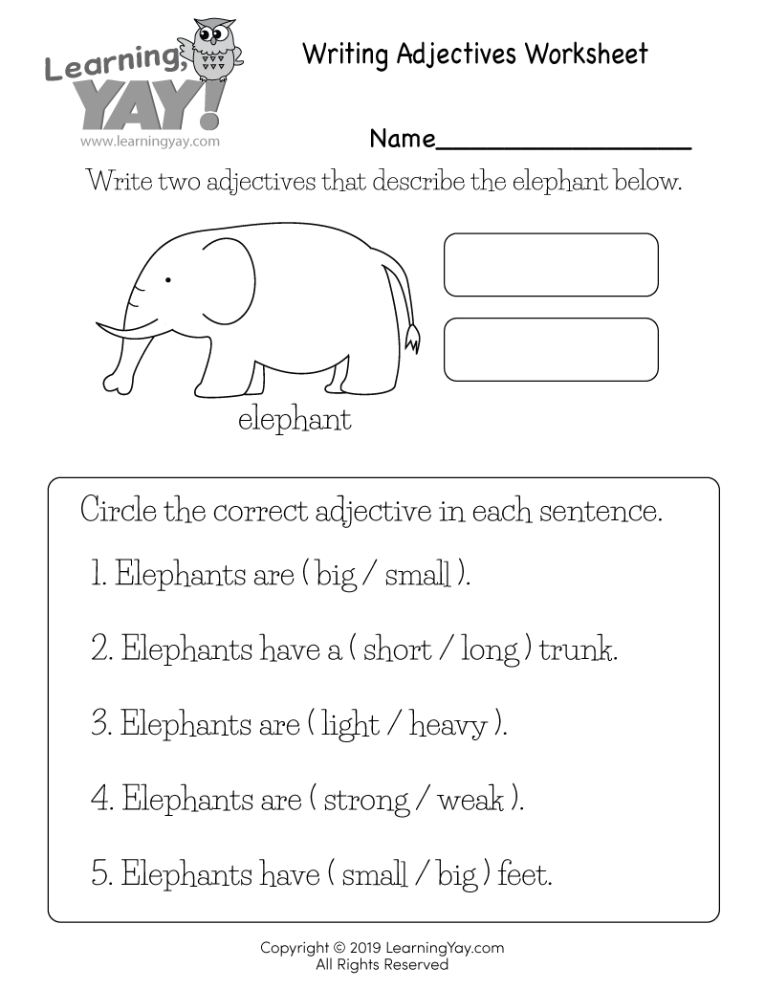

**اكتب كلمتين تصفا الفيل Write two adjectives describing the elephant.**

|  |  |  |  |  |  |  |  |  |  |  |  |  |
| --- | --- | --- | --- | --- | --- | --- | --- | --- | --- | --- | --- | --- |
| |  |  | | --- | --- | |  |  | |  |  | |  |  | |  |  | |  |  | |  |  | |

2) Write the opposite words. Use the word bank.

أكتب عكس الكلمات التالية. استعن بالمخزن.

|  |  |
| --- | --- |
| **Opposite** | **Word** |
|  | beautiful |
|  | good |
|  | poor |
|  | new |
|  | outside |
|  | clean |
|  | hot |
|  | warm |
|  | young |
|  | heavy |
|  | strong |
|  | fast |

light, slow, weak, ugly, old, bad, rich, inside, cold, dirty, cool

*********************************

3) Write three adjectives to describe each topic.

اكتب ثلاثة صفات تلائم اسم كل مجموعة.

|  |  |  |  |
| --- | --- | --- | --- |
| ***Weather*** | ***House*** | ***Friend*** | ***Animal*** |
|  |  |  |  |
|  |  |  |  |
|  |  |  |  |