Sixth Grade

Writing Task- Practice

1. **Complete the sentences with has or have according to the picture.**

**اكمل الجمل بhas او have حسب الصورة.**

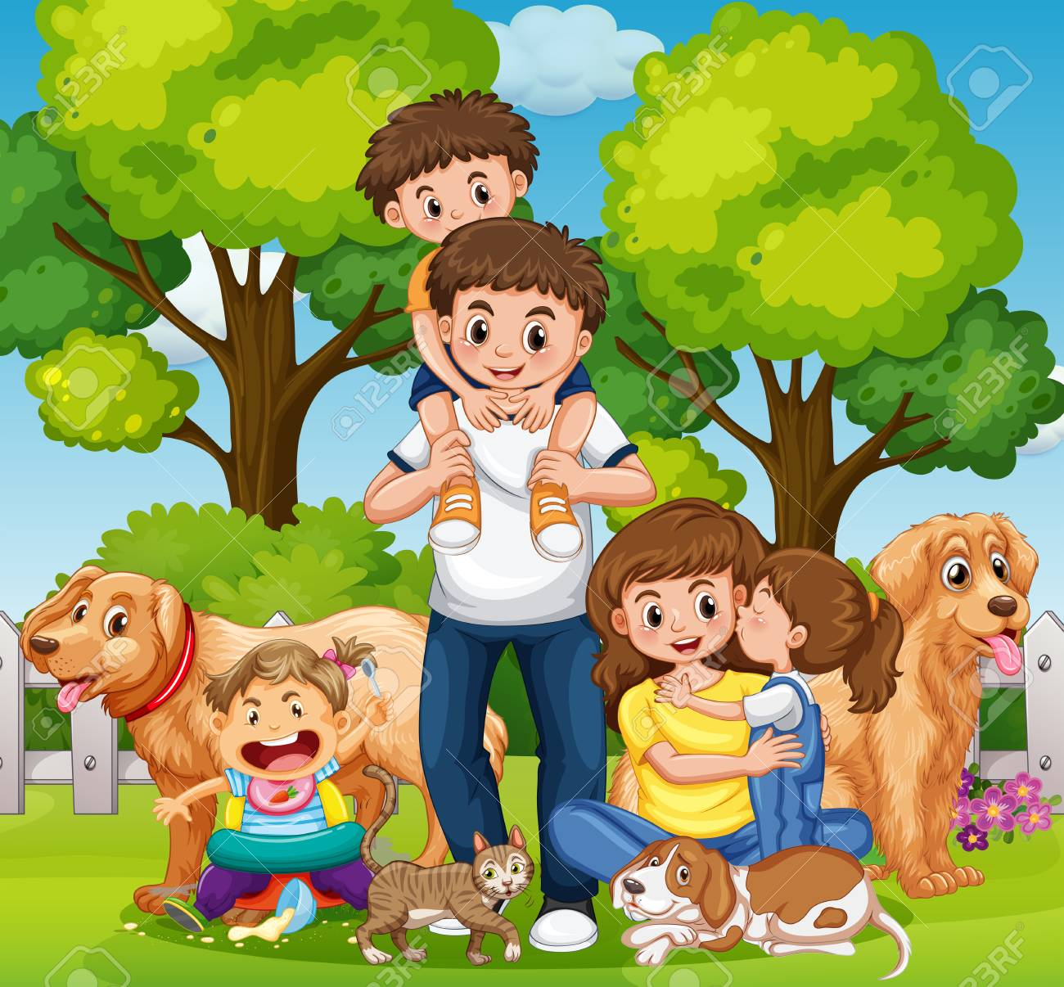

1. Mom and daughter ___________ long hair.
2. The cat __________ a long tail.
3. The dogs ____________ big eyes.
4. Dad _______ blue jeans.
5. The baby ________ a big mouth.
6. A) Draw your favorite animal. ارسم حيوانك المفضل
7. Write three sentences talking about its body.

**اكتب ثلاثة جمل تكلم فيها عن اعضاء هذا الحيوان. استعمل الفعل has .**

_______________________________________________1.

1. __________________________________________
2. __________________________________________